**Energy use of Heat Pump of a hybrid system (Heat pump + Gas Boiler) compared to a Gas Boiler system**

Base on HHS’ house model. I did a Simulation with inputs from Rob. I had modified the Thermostat values. The temperature SP now always at 20 degree.

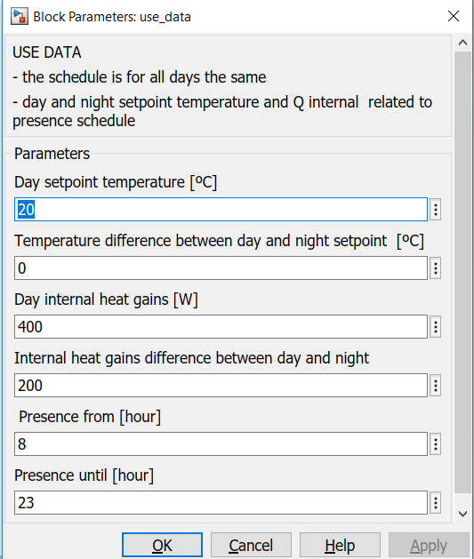

The saving amount is not much more than previous simulation 62.18 now to compare with 47.16 before.

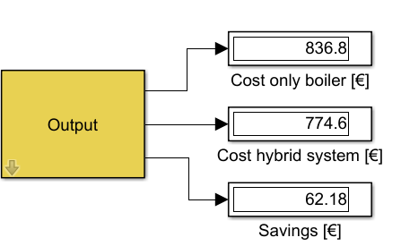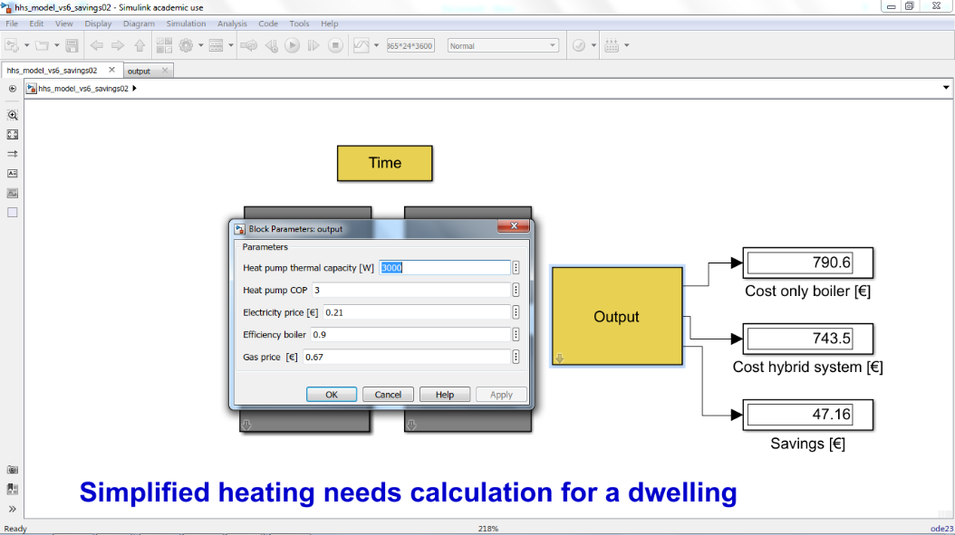

Due to the fact that hybrid Heat Pump will not bring much more benefit on cost saving. Now we are moving the focus point to see whether if we can use mainly electricity instead of gas in a hybrid system. As you can see in the pictures below, with a Hybrid system the Heat Pump delivered around 91% of the total amount of heat that is needed. The number of times that gas boiler needs to turn on is 587 times during a whole year.

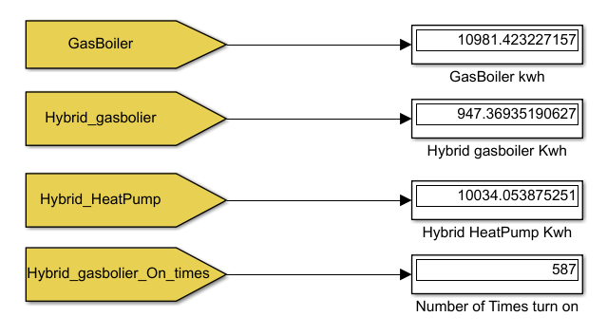

Another interesting point is if we oversize Heat Pump a little bit (from 3 to 4 kw) then the heat that is delivered by the Heat Pump increase to around 98% of the total amount. And the times that gas boiler needs to switch on also reduce to almost 3 times.

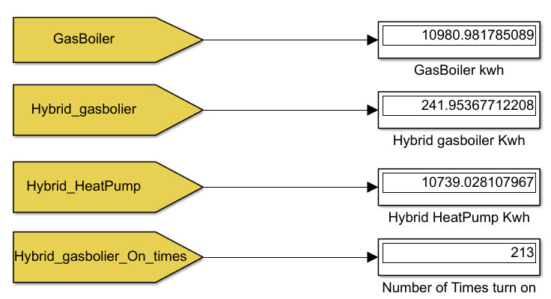

Best Regards,

Trung